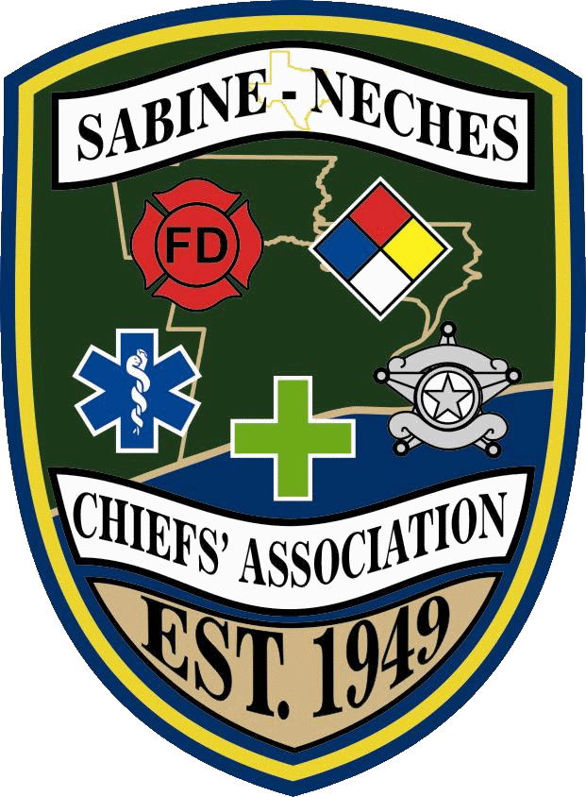

SABINE-NECHES CHIEFS ASSOCIATION
~ P.O. Box 2257 Nederland, Texas 77627 ~
Phone: (409) 960-5761, Fax: (409) 960-5766
Email: snca@ih2000.net Web: www.snchief.com
24-Hour Activation Phone: 409-838-6371

Organized Feb. 9, 1949
2011 Board of Directors

John Owens
President 11-12

Terry Basham
Vice-President 11-12

Dale Jackson
Secretary/Treasurer 11-12

Vernon Pierce
Sergeant-at-Arms 11-12

Larry Richard
Fire Director 10-11

Ann Huff
Fire Director 11-12

Tommy Wells
Industry Director 10-11

Elgin Browning
Industry Director 11-12

Aleta Cappen
Police Director 10-11

Tim Ocnaschek
Police Director 11-12

Theresa Wigley
At-Large Director 11-12

Stephanie Garsea
EMS Director 11-12

Cindy Powers
Health Director 11-12

2nd Quarter Board of Directors Meeting

M I N U T E S
April 21, 2011 5:30 pm
Quorum is (7) Voting Directors

On Thursday, April 21, 2011 at 5:59 pm, John Owens,
President of the Sabine Neches Chief’s Association called to order the 2nd Quarter Board of Directors Meeting held at the Schooner.

The following SNCA Officers were excused: Theresa Wigley, Vernon Pierce, Tommy Wells, Elgin Browning, Aleta Cappen, & Cindy Powers.

Open Meeting: Noting that a Quorum was present, President Owens opened the meeting.

Old Business:

President Owens had Chief Steve Curran give an update on the work being done on the SNCA website by Juxtapose. Chief Curran advised Board members that the web site was operational and Juxtapose had already begun posting information on the site. Chief Curran also stated Juxtapose was working on a large project in the City of Port Neches, and he was hoping that more time and effort would be given to the SNCA website once that project was completed.

President Owens also had Chief Curran give an update on the progress of the Pay Pal account. Chief Curran advised the Board that the Pay Pal account was set up and working. Chief Curran stated it had been tested and worked great, and would be available for use at the SNCA Golf Tournament.

SNCA Golf Tournament Chairperson, Stephanie Garsea, gave a preliminary report to the Board on the SNCA Golf tournament held on April 18th. Stephanie said the proceeds were estimated to be around $5,000.00. President Owens thanked Stephanie and committee for their hard work making this year’s event a huge
success.

Correspondence:

Financial Report : Secretary/Treasurer gave the following report;

 | Checks issued since last Board meeting:
01/27/2011 | Schooner | January Board Meeting |  | $ 485.59
01/27/2011 | Sylvia Florist | Ray Broussard Flowers |  | $ 89.80
01/27/2011 | Stephanie Garsea | Reimburse for golf flyers |  | $ 31.83
01/28/2011 | Elegante Hotel | Best Practices Class |  | $ 715.26
02/10/2011 | Plant-it Web Hosting | Email Account |  | $ 36.00
02/10/2011 | Edgar Kiker Cross | Financial Review |  | $ 375.00
03/28/2011 | Rockin A Café | Food for golf tournament |  | $ 70.00
04/18/2011 | Belle Oaks | Golf fees |  | $ 3,232.39
04/18/2011 | Stephanie Garsea | Reimburse various golf expenses |  | $ 91.75
 |  | Account Balances
 |  | Checking Balance |  | $27,472.12
 |  | CD Balance |  | $ 4,967.86
 |  | CD #2 Balance |  | $ 5,000.00
 |  | Total Balance |  | $37,439.98
Note: Checking account balance includes restricted revenue
collected to date for SNCA scholarship golf tournament

The President called for a motion to approve the Treasurers Report; Larry Richard made the motion to approve the Financials and Anne Huff seconded the motion. The motion carried.

New Business:
President Owens opened discussion on an application for membership from the Port Arthur Health Department. President Owens read the letter of recommendation from the Port Arthur Fire & Police Department, and noted all proper paperwork was attached with the application.

President Owens opened discussion on an application for membership from Cray Valley LLC, located in Beaumont. The sponsor letter from Goodyear was read, and it was noted that all the proper paperwork was attached with the application.

President Owens asked for any discussion on either of the applications presented to the board, and with no discussion being heard asked for a motion.

Terry Basham made a motion to accept both applications for consideration as members of the SNCA, the motion was seconded by Stephanie Garsea. Motion carried.

President Owens stated the tow applicants will be brought to the membership at the next meeting in May.

President Owens discussed the possibility of having future board meetings at lunch instead of an evening meeting. President Owens suggested that the board meet next quarter at lunch, at a location to be determined at a later date. The next board meeting is scheduled for Thursday, July 28, and this date is tentative.

Secretary Treasure Dale Jackson made a request that the Constitution and By-Law committee look at setting up a protocol for transactions made through Pay Pal, guidelines on what paperwork to keep and how to do the reporting for audit purposes. President Owens stated he would have the Constitution and By-Law committee look at establishing guidelines for Pay Pal.

SNCA Board of Directors Meeting Schedule 2011:
Thursday, January 27
Thursday, April 28
Thursday, July 28
Thursday, October 27

Call for motion to adjourn:
Motion made by Terry Basham, seconded by Tim Ocnaschek to adjourn. Motion carried.

Meeting Adjourned: 6:51 pm

Dale Jackson
Secretary/Treasurer

